A000-Asia-Central-Zebu Figure-Bronze-1500 BCE

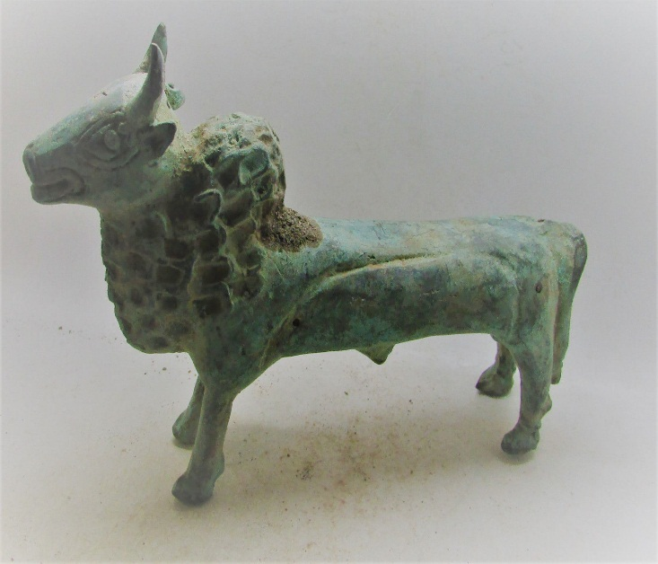 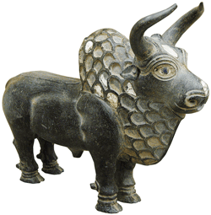

E Iran,,W Central Asia-Zebu-Cast Bronze late 3rd to early 2nd millennium BCE

Right Fig. Miho Museum, 529-1814 Shigaraki-cho, Shigaraki-shi, Shiga prefecture Toshiro Momotani Japan. 300https://i.pinimg.com/originals/40/de/78/40de78f6fbe2bd8ae5cec4bf9564a950.gif

Hittite processing of metals was done by smiths (LÚSIMUG) and metalworkers, LÚTIBIRA with specialized branches of these occupations headed by gold- and silversmiths (LÚKU3 .DÍM) who functioned as treasurers and were one of the most influential officials of the state administration.(Siegelová 1986: 119-20).

Siegelová, J.1986. Hethitische Verwaltungspraxis im Lichte der Wirtschafts- und Inventairdokumente, 3 vols. Prague: Národni Muzeum.